GRANARD MUNICIPAL DISTRICT

Minutes of Meeting of Granard Municipal District held in the Granard Community Library, on Tuesday, 28th February 2017 at 3.30 p.m.

CATHAOIRLEACH: Councillor P.J. Reilly

MEMBERS PRESENT: Councillors – Paraic Brady, Michael Carrigy, Luie McEntire and Martin Mulleady.

IN ATTENDANCE: Mr. John Brannigan, Director of Services.
Mr. David Tubridy, Senior Engineer
Mr. Aidan Naughton, Acting Senior Executive Engineer.
Ms. Ann Marie McKeon, Administrative Officer.

A/ MEETINGS
ADMINISTRATOR: Ms. Mary Cooney.

SCHEDULE OF GRANARD MUNICIPAL DISTRICT WORKS.

The Schedule of Municipal District Works 2017, as circulated with the Agenda, was
considered by the members.

The Cathaoirleach, on behalf of the members thanked the Executive for putting the Roads programme together.

A. Naughton replied to queries raised on the following issues:-

- L1013 inclusion in the Three Year Programme.
- L1094 Newtownforbes end of lane at Mulleady's factory on Drumlish Road.
- Watermains at Carragh Church
- Drumlish to Newtownforbes Road

J.Brannigan undertook to re circulate the Three Year Programme to Councillors.

On the proposal of Councillor L. McEntire seconded by Councillor M. Carrigy, it was unanimously agreed to adopt the Schedule of Municipal District Works 2017, as circulated.

A.O.B.

- Boundary Fencing for Housing Estates -
Councillor Mulleady asked where responsibility lies for boundary fencing in Housing Estates taken in charge and whether fencing can be concrete panel or block wall rather than timber.
J. Brannigan will raise with Planning to see whether this can be added into planning conditions.

- Street cleaning budget was confirmed to be unchanged from 2016.

- Hedgecutting and enforcement.

- Recovery of costs from landowners arising from the provision of emergency services provided for tree removal after severe storms.

- Additional funding required for flash flooding after severe storms.

- Pedestrian Crossing for Mill Road, Drumlish. Application to be made under Low Cost Safety Scheme.

- Extension of continuous white line from Lennons to the Bandra Road.

- Road to be resurveyed for PSCI (Drumlish to Ballagh Road).

This concluded the business of the meeting.

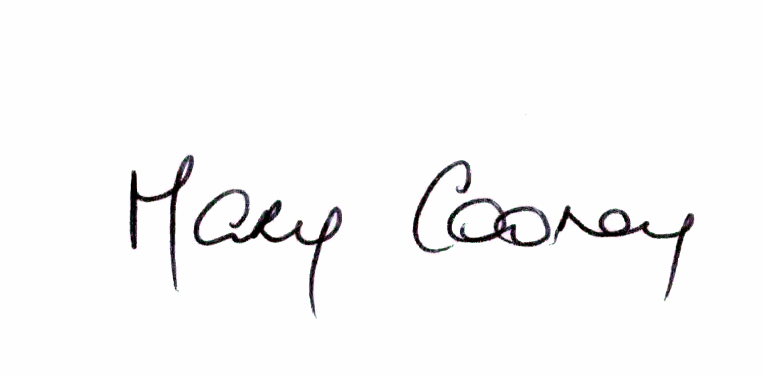

Signed: ____________________
Mary Cooney,
A/ Meetings Administrator.

Confirmed and adopted at Granard Municipal District Meeting held on the
28th March 2017.

Signed: _______________
Cathaoirleach.

